Recreational Gymnastics
Summer Camp at Elite Gymnastics Center

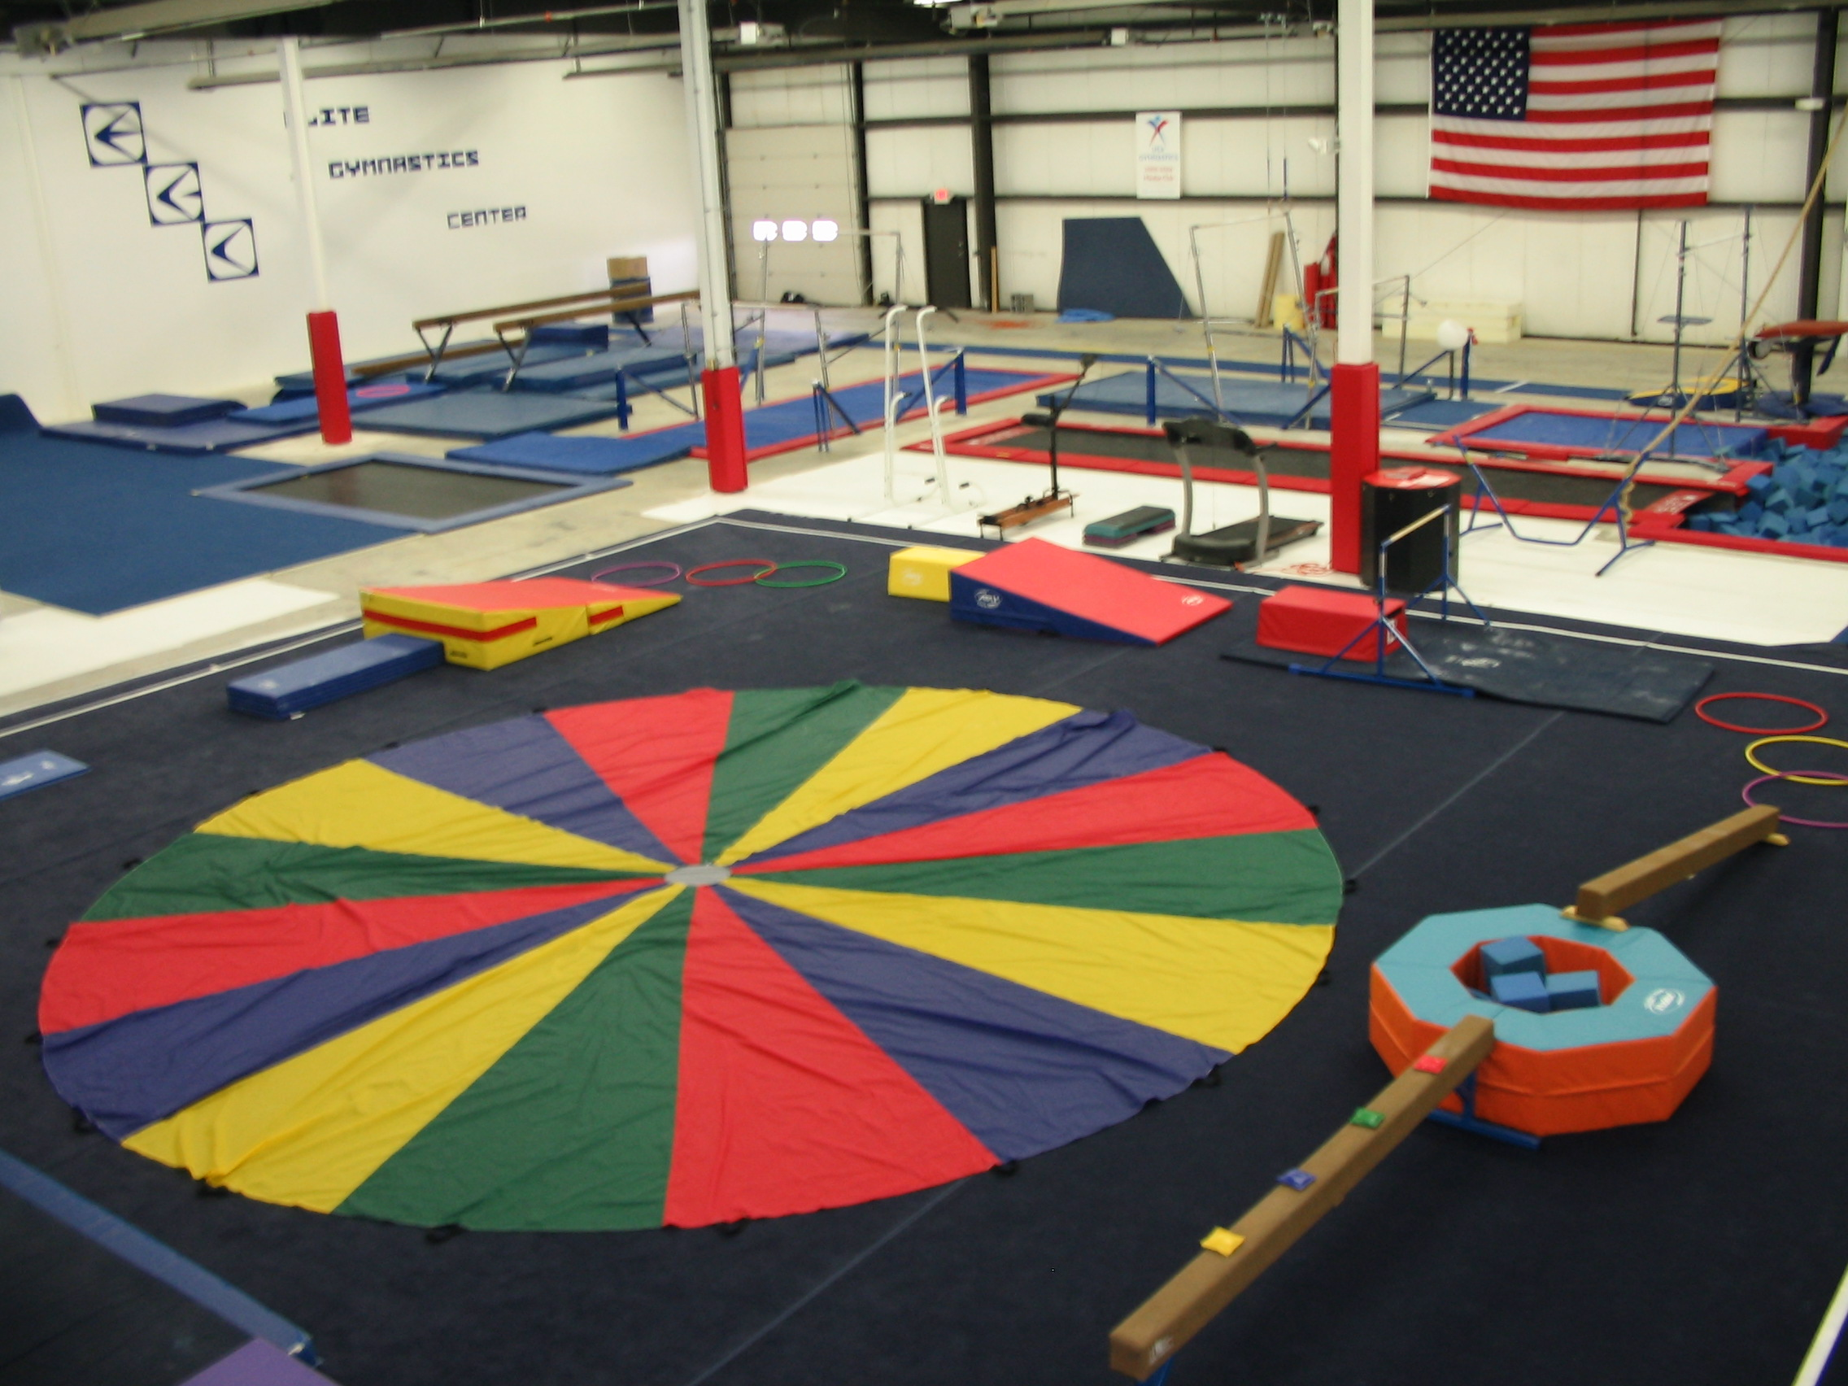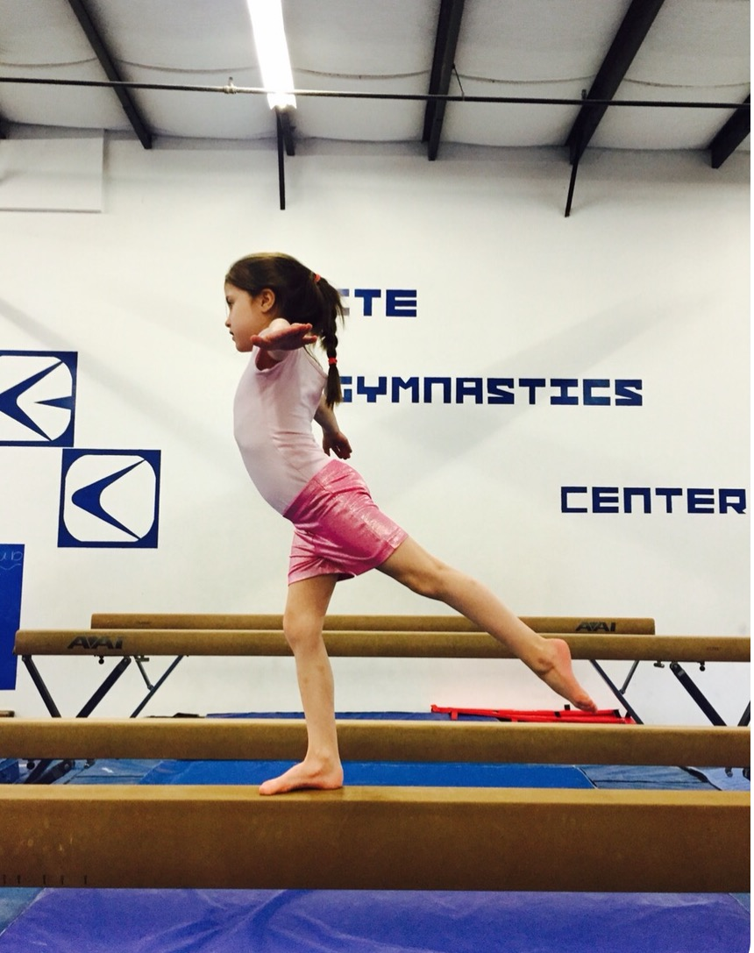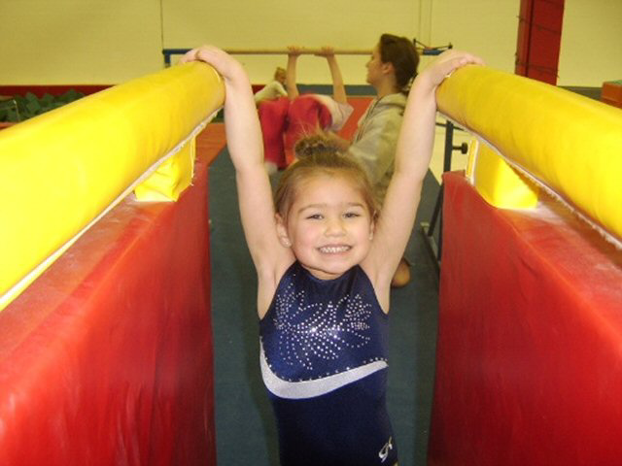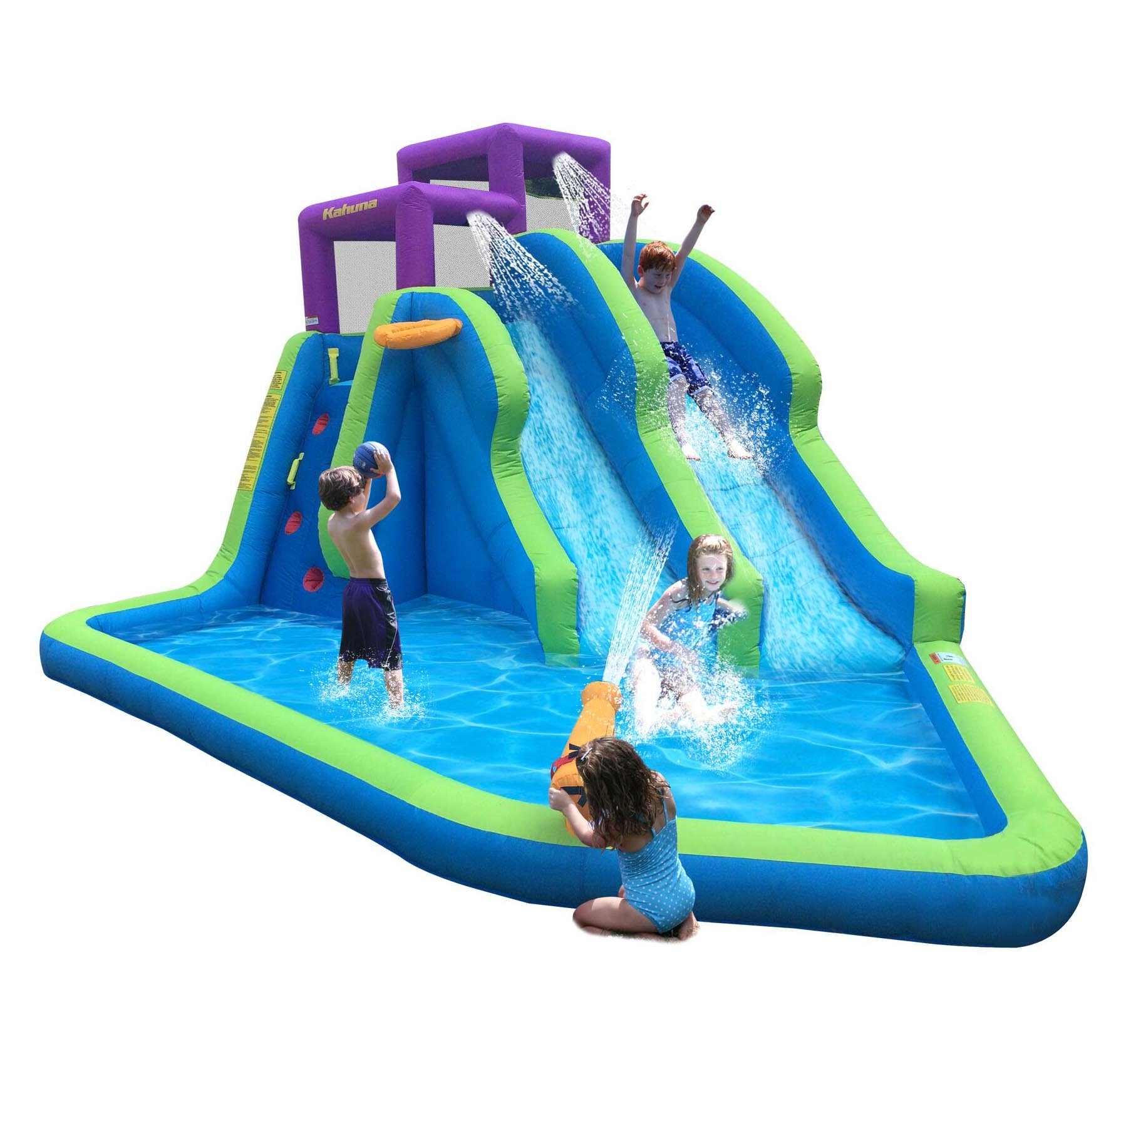

Join us for fun filled days with games, bounce house, air floors, 30-foot-long in-ground trampoline into 20 X 17 foam pit and Gymnastics, Gymnastics, Gymnastics!!!
Outdoor gymnastics, water balloons, water slide, arts & crafts, and outdoor activities
- weather permitting. * Activities are determined by age of child. *
____ Week 1 June 24th - June 28th ____ Week 5 July 29th - August 2nd
____ Week 2 July 8th - July 12th ____ Week 6 August 5th - August 9th
____ Week 3 July 15th - July 19th ____ Week 7 August 12th - August 16th
____ Week 4 July 22nd - July 26th
We are always willing to add additional camp weeks. Reserve now for your special group.
~YOU MUST PRE-REGISTER~
LIMITED NUMBER OF SPOTS AVAILABLE
~SUMMER CAMP IS FOR CHILDREN AGES 5 AND UP~

Please check the dates above that your child/children will attend.
Please send water bottles and a healthy snack (no sugary snacks) and/or lunch.
There will be NO sharing food.

_____ 3 Half Days $175.00 _____ 5 Half Days $225.00
_____ (9:00 am - 12:00 pm) _____ (9:00 am - 12:00 pm)
_____ (12:30 pm - 3:30 pm) _____ (12:30 pm - 3:30 pm)
Circle: Monday Tuesday Wednesday Thursday Friday
1 Day Drop-in Fee: $60.00 (half-day)
Limited Full Days are available. Call for details!

Registration Fee: A $15.00 registration fee is required for all new EGC members.
10% sibling/multiple week discount (second child or class)
Note: A non-refundable $50.00 deposit is required to hold each week’s spot.
Please e-mail us at elitegymnastics@sbcglobal.net if you have any questions.
Kindly fill out the Registration Form on the reverse side.

