SPRING BREAK GYMNASTICS
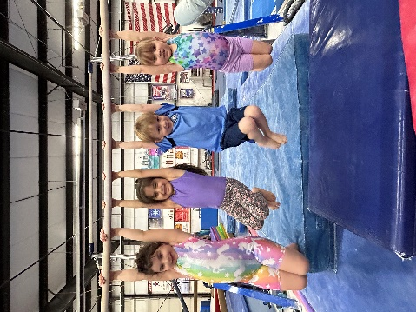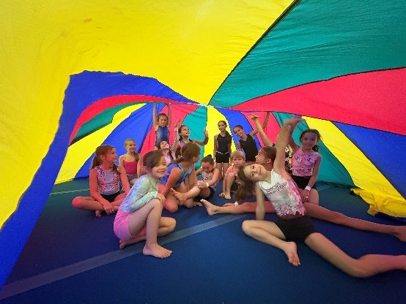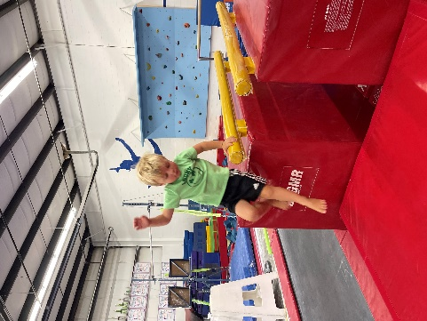
Monday, April 13th – Friday, April 17th
Half Day 9-12 or 12-3 or Full Day 9-3
Full Day Pricing: $100/day or $380/week
Half Day Pricing: $55/day
Parents are responsible for packing plenty of healthy snacks and water. For those attending full day, please provide a nutritious lunch.
Sibling discount is available. Open to members and non-members.
Spring Break Gymnastics is for children ages 5 and up.
Please reserve your child’s spot in advance by leaving a
$25 non-refundable deposit per child/per day.
You may sign up at the desk, call our office at 860-354-5479,
or email us at elitegymnastics@sbcglobal.net.

We look forward to keeping your children busy and returning them tired to you.

