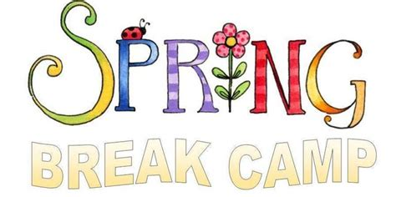
Monday, April 15th – Friday, April 19th
9:00am – 12:00pm or 12:00pm – 3:00pm – half day
$60 – One half-day
$120 – Two half-days
$175 – Three half-days
$200 – Four half-days
$225 – Five half-days
* 9:00am - 3:00pm – full day
*There are a limited number of full day spots available.
Sibling discount is available. Open to all members and non-members.
Camp is for children ages 5 and up.
Half-day – please pack healthy snacks and a water bottle.
Full day - please pack a healthy lunch, snacks and a water bottle.
Please reserve your children’s spot in advance by leaving a $25 deposit per child/per day. You may sign up at the desk, call our office at
860-354-5479, or e-mail us at elitegymnastics@sbcglobal.net.
We look forward to keeping your children busy
and returning them tired to you.

