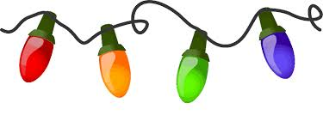 Winter Camp 2025
Monday, December 29th
Tuesday, December 30th
Friday, January 2nd
9:00am - 12:00pm or 12:00pm - 3:00pm half-day
9:00am - 3:00pm full day
Pricing
$60 - One half-day or $85 - One full day
$100 - Two half-days or $150 - Two full days
$150 - Three half-days or $200 - Three full days
Sibling discounts are available. Open to all members and non-members.
Camp is for children ages 5 and up.
Full day - Pack a healthy lunch, snacks, and a water bottle.
Half-day - Pack healthy snacks and a water bottle.
Please reserve your children’s spot in advance by leaving a
$25 non-refundable deposit per child/per day.
You may sign up at the desk, call our office at 860-354-5479,
or e-mail us at elitegymnastics@sbcglobal.net.
We look forward to keeping your children busy
and returning them tired to you!

